# RECIPE SHARING WEBSITE

### A MINI PROJECT REPORT

#### Submitted by

#### Group/Team No: G21-A/T2

NAME OF THE STUDENT1: HARSAINYAM SINGH

ROLLNO: 2310991840

NAME OF THE STUDENT2: HARSHDEEP SINGH

ROLLNO: 2310991841

NAME OF THE STUDENT3:

HARSHDEEP SINGH

ROLLNO: 2310991842

#### in partial fulfillment for the award of the degree of

## BACHELEOR OF ENGINEERING

*in*

COMPUTER SCIENCE & ENGINEERING



CHANDIGARH-PATIALA NATIONAL HIGHWAY

RAJPURA (PATIALA) PUNJAB-140401 (INDIA)

6 December 2023

**Abstract**

In the realm of digital innovation, the “FoodZee” website emerges as a pioneering platform designed to foster community engagement and culinary exploration through food sharing. Crafted as part of a university project, “FoodZee” encapsulates the essence of a user-centric approach, seamlessly blending functionality and aesthetics to create a delightful online culinary experience.

The website is meticulously developed using HTML and CSS, showcasing a sleek and intuitive design that captivates users from the moment they land on the homepage. Navigating through FoodZee is an effortless journey, thanks to its user-friendly interface, strategically placed navigational elements, and visually appealing layout. The website's responsiveness ensures a seamless experience across various devices, catering to the diverse needs of its user base.

At its core, FoodZee is not just a collection of recipes but a dynamic hub for culinary

enthusiasts to share, explore, and connect. Users can effortlessly upload their favorite recipes, accompanied by captivating images and detailed instructions. The platform promotes a sense of community by enabling users to comment, ask questions, and provide feedback on each other's creations, fostering a collaborative and interactive space.

FoodZee distinguishes itself by incorporating innovative features such as personalized user profiles, allowing individuals to curate their own recipe collections and showcase their culinary expertise. The search functionality is robust, employing tags and categories to enhance discoverability and ensure that users can easily find recipes aligned with their preferences and dietary restrictions.

In addition to being a repository of diverse recipes, FoodZee also recognizes the importance of education in the culinary arts. The website includes a dedicated section for articles, tutorials, and cooking tips, providing valuable insights for both novice and experienced chefs. This commitment to knowledge-sharing reinforces FoodZee's position not only as a recipe repository but also as an educational platform for culinary enthusiasts.

The aesthetic appeal of FoodZee is not merely superficial; it reflects a deliberate effort to create a visually engaging platform that enhances the overall user experience. From high-quality images accompanying each recipe to the thoughtfully designed color scheme, the website's aesthetics are harmoniously aligned with its culinary theme.

In conclusion, FoodZee stands as a testament to the synergy between smart web development, user-centric design, and a passion for culinary exploration. This food sharing website transcends the conventional boundaries of recipe platforms by fostering a sense of community, encouraging knowledge exchange, and providing an aesthetically pleasing digital space for all culinary enthusiasts to savor.

###### TABLE OF CONTENTS

###### 

|  |  |  |
| --- | --- | --- |
| Sno. | Section | Page No. |
| 1 | Introduction | 3 |
| 2 | Problem Statement | 4 |
| 3 | Technical Details | 5-7 |
| 4 | Key Features | 8-9 |
| 5 | Bonus Features | 10 |
| 6 | Conclusion | 14 |

INTRODUCTION

FOODZEE: Recipe Sharing Website

Welcome to Foodzee! Here, you can find and share all sorts of delicious recipes. It doesn't matter if you're experienced or just starting out in the kitchen – everyone is welcome. Explore a wide variety of recipes, connect with other food lovers, and enjoy the fun of cooking and sharing your favorite dishes.

Get ready to discover new flavors and recipes from around the world, all in one place! Our recipe sharing platform is designed to make cooking and sharing recipes as easy as possible.

User can Connect with fellow food enthusiasts, share your creations, and exchange tips and tricks. You can leave comments, rate recipes, and can even create your own video recipes and upload them.

Our website Provides a user-friendly and easy to navigate interface. Search for recipes, filter by ingredients, or explore trending dishes with just a few clicks. With just a click of button people can view food news get know more about new recipes and about foods to maintain their health. Created as a university project, Foodzee is a blend of HTML, CSS, BootStrap and JavaScript

Why Need A Recipe Website?

A food sharing website serves as a valuable platform for a variety of reasons

contributing to an enriched culinary experience and fostering a sense of community among food enthusiasts. Here are several compelling reasons for the need for a food sharing website:

1. **Community Building:**

Networking: A sharing website brings together individuals with a common interest in food, creating a vibrant online community. Users can connect, share experiences, and build relationships based on their mutual love for culinary exploration.

2. **Knowledge Exchange:**

Learning Opportunities: By allowing users to share their recipes, tips, and tricks, a food sharing website becomes a hub for knowledge exchange. Novice cooks can learn from experienced chefs, fostering a continuous learning environment.

3**. Diverse Culinary Exploration:**

Recipe VarietyA sharing platform facilitates the exchange of a wide range of recipes from different cuisines, dietary preferences, and skill levels. This diversity provides users with a plethora of options, encouraging them to try new dishes and broaden their culinary horizons.

**4. Inspiration and Creativity:**

Creativity Boost: Seeing and trying out recipes from other users can inspire creativity in the kitchen. Users may be encouraged to experiment with ingredients, techniques, and presentations, leading to the development of unique and innovative dishes.

5. **Personalized Collections:**

User ProfilesA food sharing website typically allows users to create personalized profiles where they can curate their favorite recipes. This feature enables individuals to build a digital collection of recipes tailored to their taste preferences and cooking style.

6. **Interactive Feedback:**

Community Engagement:Users can engage with one another by commenting on recipes, asking questions, and providing feedback. This interactive element not only enhances the user experience but also creates a supportive environment for culinary enthusiasts to share their passion.

7. **Social Sharing:**

Wider Reach: With social sharing functionalities, users can easily share their favorite recipes on external platforms, expanding the reach of the community. This helps in attracting new members and promoting the website's content.

8.**Educational Resources:**

Tutorials and Articles: In addition to recipes, a food sharing website may include educational content such as cooking tutorials, articles, and tips. This further establishes the platform as a valuable resource for individuals looking to enhance their culinary skills.

**9. Adaptability and Accessibility:**

Cross-Device Compatibility: A well-designed food sharing website ensures accessibility across various devices, allowing users to engage with the platform seamlessly whether they are using a computer, tablet, or smartphone.

In **summary**, a food sharing website addresses the social, educational, and inspirational aspects of the culinary world. By providing a digital space for users to connect, learn, and share, such a platform becomes an essential tool for individuals passionate about the art of cooking and gastronomy.

This Recipe Provides a better medium and environment to Share all your recipes comments and Thoughts about a Recipe. People can share Recipes Through Text and videos As they like. People can get a generated recipe from The Ingredients They want so That people can enjoy Every Single bite of food .Overall Recipe Sharing Website is a great Way to Share your feelings and recipes through comments and other things.

In this report, we're going to show you around FoodZee and explain why it's a breeze to use. Whether you're a cooking pro or just starting out, we want you to feel at home here. FoodZee is a place where we can all come together and have fun with cooking.

User Rating -:

Implementing a user rating system in a recipe website is a strategic move to enhance user engagement and provide valuable feedback. The introduction of a rating system adds a layer of interactivity, enabling users to express their opinions and experiences with each recipe. This feature not only empowers users but also serves as a dynamic tool for the continuous improvement of the platform.

By allowing users to rate recipes on a scale or through a star system, the website facilitates a quick and intuitive way for individuals to communicate their satisfaction levels. This instant feedback is invaluable for both the creators of the recipes and those seeking culinary inspiration. Users can make informed decisions about which recipes to try based on the ratings and reviews provided by their peers, creating a sense of community-driven trust.

PROBLEM STATEMENT

People often struggle to find and share recipes in a convenient way. This makes it hard to try new dishes, connect with others who love cooking, and keep their kitchen organized. Many food lovers struggle with the hassle of finding recipes that suit their tastes and dietary preferences, organizing their favorite dishes in one place, and easily sharing their culinary creations with friends and family. This lack of an efficient and user-friendly recipe sharing platform limits their ability to explore diverse cuisines, learn from others, and make the most of their cooking experience. On internet Finding recipes is as difficult as finding needle in a haystack. There aren’t many stable platform to share all recipes whether it is video recipes or written recipes. Out there are not many recipe generators which give you recipes based on user given ingredients.

The absence of a reliable mechanism to assess recipe quality poses a significant challenge. Users often struggle to discern the credibility and appeal of a recipe, resulting in a hesitation to try new dishes. Establishing a trustworthy environment where users can confidently explore and experiment with recipes is paramount to the success of a recipe sharing platform. Many existing platforms lack personalized features that cater to the unique preferences and dietary restrictions of individual users. A one-size-fits-all approach may not align with the diverse tastes and needs of the culinary community, limiting the platform's ability to offer a tailored and enjoyable user experience.

We want to make this easier for the users to share recipes online, and we accepted this challenge to find a way to simplify recipe sharing online, making it accessible to everybody and everyone.

TECHNICAL DETAILS

FRONT END -:

HTML (Hypertext Markup Language) -: HTML is the base of our main website. It is Used to make the structure of a website which include different tags.

HTML5-: Html5 is just html but with added features such as audio video

support.



CSS (Cascading style sheet)-: CSS is used for styling our structure made by

HTML, such as adding colors, styles, animations and much more.



RESPONSIVE DESIGN-:

To make sure that our website is working on every single device responsive web design methods were used. Because of these methods our website can adapt to desktop, tablet, mobile phones laptops etc.

INTERACTIVE USER INTERFACE-:

Our user interface was designed with user experience in mind.This includes user friendly recipe sharing forms for recipe submission and search function to make it easy to find recipes. There are much more interactive things on our website to make sure user enjoys each and every moment on our website.

FILE ORGANISATION-:

Files of our website were organized into different categories , and maintained properly by adding different files into different folders so that it is easy to modify or change the content of our website.

HYPERLINKS AND NAVIGATION-:

All Hyperlinks and navigation were created in html to help user navigate through different pages. Proper link structures ensures a smooth browsing experience.

BROWSER COMPATIBILTY-:

FoodZee was tested in various web browsers (e.g., Chrome, Firefox, Safari, and Edge) to ensure it functions correctly and looks good across the board.

TAGS USED IN THIS WEBSITE-:

1. Title tag
2. Division tag
3. Anchor tag
4. Hyper reference tag
5. Image tag
6. Video tag
7. Font tag
8. Hr tag
9. Marquee tag
10. Heading tag
11. Footer tag
12. Table tag
13. External CSS
14. Internal CSS
15. Inline CSS

BOOTSTRAP -:

A technique of loading a program into a computer by means of a few initial instructions which enable the introduction of the rest of the program from an input device. The technique of starting with existing resources to create something more complex and effective:

**1. Introduction to Bootstrap:**

* + - Bootstrap as a Web Development Toolbox
    - Streamlining Design with Pre-designed Components

1. **Key Features of Bootstrap:**
   * Responsive Design for All Devices
   * Time and Effort Saving with Ready-to-Use Components
2. **Functionality of Bootstrap:**
   * Components like Buttons, Forms, Navigation Bars
   * Ensuring Consistent and Appealing Design Across Devices
3. **Metaphor:**
   * Bootstrap as a Helpful Friend in Web Design

JAVASCRIPT -: An object-oriented computer programming language commonly used to create interactive effects within web browsers.

**JAVASCRIPT:**

1. **Introduction to JavaScript:**
   * JavaScript as the Dynamic Language for Web Interaction
   * Enhancing Websites with Real-Time Functionality
2. **Purpose of JavaScript:**
   * Creating Interactive and Engaging Web Experiences
   * Adding Life to Otherwise Static Websites\
3. **Capabilities of JavaScript:**
   * Pop-ups and Modal Windows
   * Content Updates Without Page Refresh
4. **Metaphor:**
   * JavaScript as the Spice That Elevates the Website Flavor



SECURITY-:

Many different measures were taken to protect user data such as their email id’s, passwords, login details and more personal imformation.

HTML Structure:

1. **Document Type Declaration (<!DOCTYPE html>):**
   * Specifies the document type and version of HTML.
2. **HTML Root Element (<html>):**
   * The root element that contains the entire HTML document.
3. **Head Section (<head>):**
   * Contains meta-information about the HTML document.
   * Meta tags for character set and viewport settings.
   * Link to the Bootstrap CSS file.
4. **Body Section (<body>):**
   * Contains the content of the HTML document.
5. **Navbar (<nav>):**
   * Bootstrap's navigation bar with a brand logo and navigation links.
6. **Main Container (<div class="container">):**
   * Bootstrap container for centralizing content.
   * Contains the main content of the page.
7. **Heading and Form (<h2>, <form>):**
   * Heading for the page.
   * Form for submitting reviews with input fields for name, comment, and hidden input for rating.
8. **Rating Buttons Container (<div class="rating-btn-container">):**
   * Container for rating buttons (1 to 10).
9. **Review Container (<div class="review-container">):**
   * Container for displaying submitted reviews.
   * Uses a 3D flip effect with CSS animations.
10. **JavaScript Libraries (<script>):**
    * Links to jQuery, Popper.js, and Bootstrap JavaScript libraries.
11. **JavaScript Code (<script>):**
    * JavaScript code for dynamic star rating, pop-up notification, and submitting reviews.
    * Functions for setting ratings, submitting reviews, and animations.

**CSS Styling:**

1. **Global Styles:**
   * Styling for the body, background color, and default styles for various elements.
2. **Navbar Styles:**
   * Styling for the navigation bar, including background color, box shadow, and text alignment.
   * Brand logo with rounded corners.
3. **Container Styles:**
   * Styling for the main content container, including background color, padding, border radius, and box shadow.
4. **Review Container Styles:**
   * Styling for the container displaying reviews.
   * 3D flip effect using perspective and transform properties.
   * Animation for sliding in reviews.
5. **Rating Button Styles:**
   * Styling for the rating buttons, including background color, text color, padding, font size, and border radius.
   * Hover effect for changing background color.

**JavaScript Interactions:**

1. **Dynamic Star Rating**:
   * Creation of star elements dynamically.
   * Event listener for clicking on stars to set the rating.
2. **Submitting Reviews:**
   * Function to submit reviews.
   * Validation for ensuring name, comment, and rating are provided.
   * Creation of a new review element with a 3D flip effect.
3. **Rating Buttons Interaction:**
   * Functions for setting the rating when clicking on the rating buttons.
4. **Libraries:**
   * Use of jQuery, Popper.js, and Bootstrap JavaScript for enhanced functionality and styling.

Technical Details(II)

1. Home Page

The home page of our recipe sharing website, crafted with a seamless blend of HTML, CSS, and JavaScript, is designed to captivate users from the moment they land on the site. The interface is a visual feast, featuring an elegant and intuitive layout that beckons culinary enthusiasts to explore the world of flavors within. Dynamic animations add an extra layer of engagement, as ingredients gracefully cascade into view, and images of delectable dishes subtly fade in, creating a delightful sensory experience.

The popular Recipes section welcomes users with a tastefully curated slideshow of mouthwatering dishes, accompanied by subtle transition effects that evoke a sense of anticipation. The navigation bar, adorned with sleek icons, smoothly transforms as users scroll, maintaining visibility and accessibility throughout their culinary journey. A responsive design ensures that the website adapts seamlessly to various screen sizes, enhancing accessibility for users across devices.

In conclusion, the home page of our recipe sharing website is a harmonious convergence of HTML, CSS, and JavaScript, offering a visually stunning and interactive gateway to the world of culinary delights. The animations not only elevate the aesthetic appeal but also contribute to a user-centric experience, inviting individuals to embark on a culinary journey that is as visually enticing as it is informative and engaging.

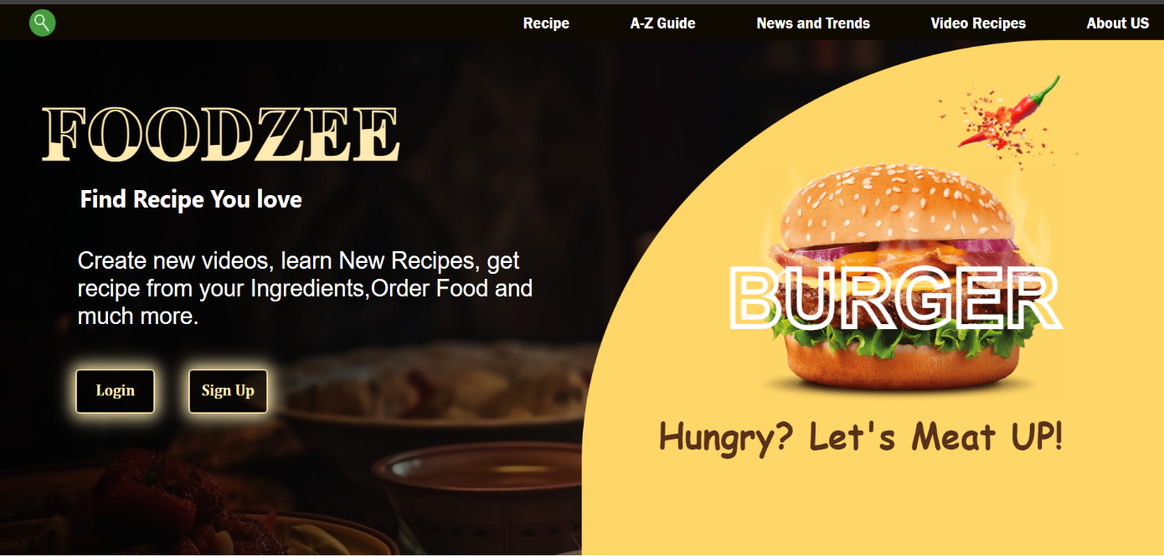

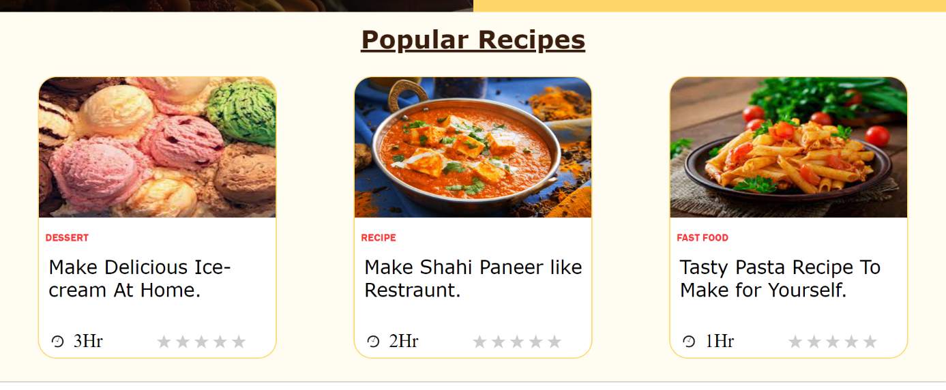

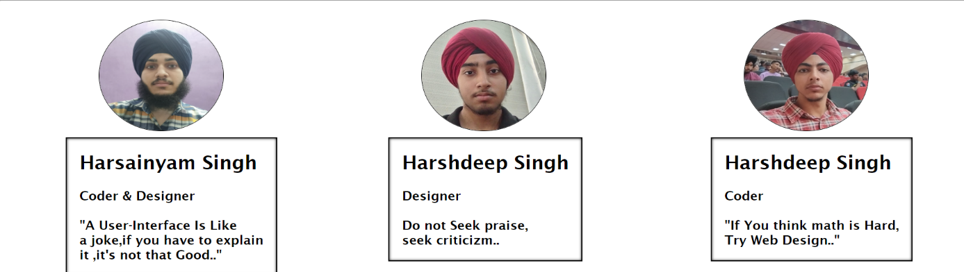

B) News And Trends-:

In the dynamic world of culinary exploration, staying abreast of the latest news and trends is essential for every passionate home cook. Our recipe sharing website recognizes the importance of not only providing an extensive collection of mouthwatering recipes but also keeping our community informed and inspired. The "News and Trends" page serves as a virtual culinary newspaper, delivering a delectable blend of food-related updates, emerging trends, and insightful articles to nourish the minds of our users.

The "News and Trends" page serves as a hub for culinary enthusiasts to stay informed about current events in the world of food. From the latest food festivals and chef collaborations to breakthroughs in culinary technology, our curated content ensures that users are well-versed in the ever-evolving landscape of gastronomy.

Our dedicated team of culinary experts scours the culinary world to identify emerging trends and innovative cooking techniques. The page features in-depth articles and analyses, offering users a glimpse into the forefront of the culinary arts. From fermentation trends to avant-garde cooking methods, we strive to inspire our community to experiment and push the boundaries of their culinary creativity.

The "News and Trends" page on our recipe sharing website is more than just a repository of information; it's a celebration of the ever-evolving world of food. By providing a carefully curated blend of news, trends, and educational content, we aspire to enrich the culinary journey of our users, keeping them inspired, informed, and excited to explore new horizons in the world of flavor.

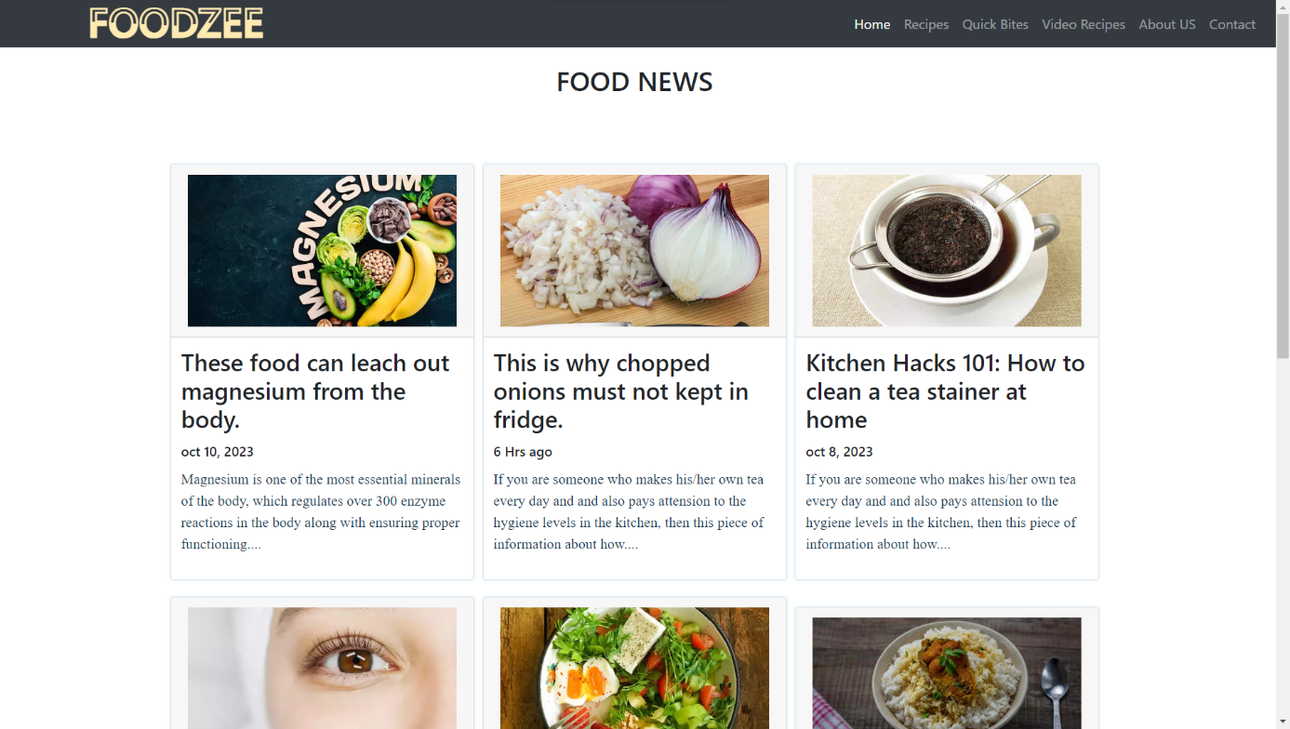

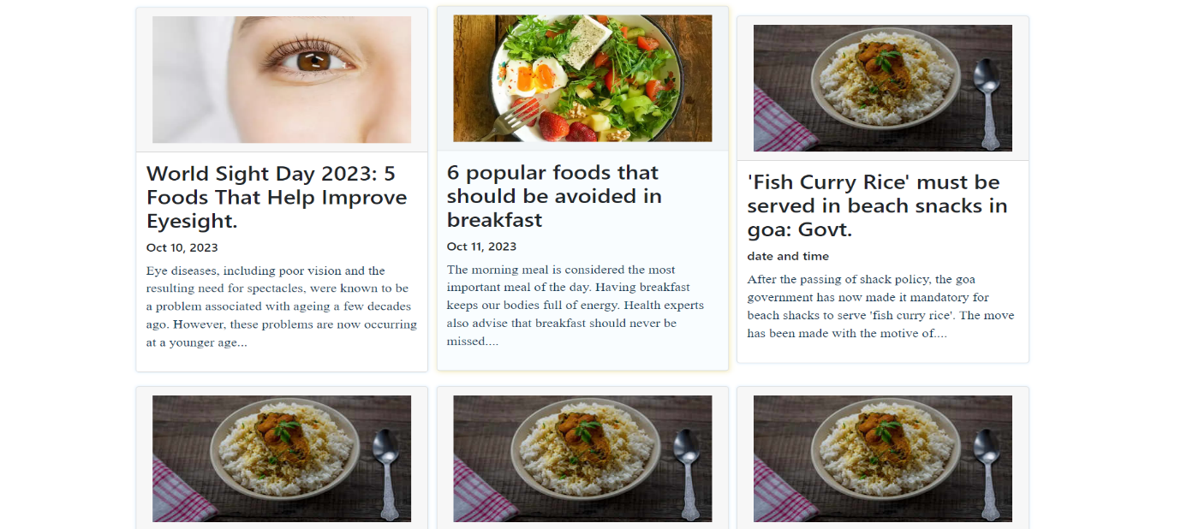

1. Login And Sign UP Page:

This page is designed to collect contact information from potential customers, such as their name, email address, and phone number. A user should enter Firstname, Secondname, Email and Password. "Reset" and "Submit" button have been provided.In this page, JavaScript has been used to make the page operational. Moreover, it is a signup page so it requires a lot of functions of JavaScript such as we have used, onmouseup(), onmousedown(), onfocus, onsubmit, onreset and alerts. Internal CSS has been used to give the website the proper look it needs. New Animations has been added in Sign Up and login page.

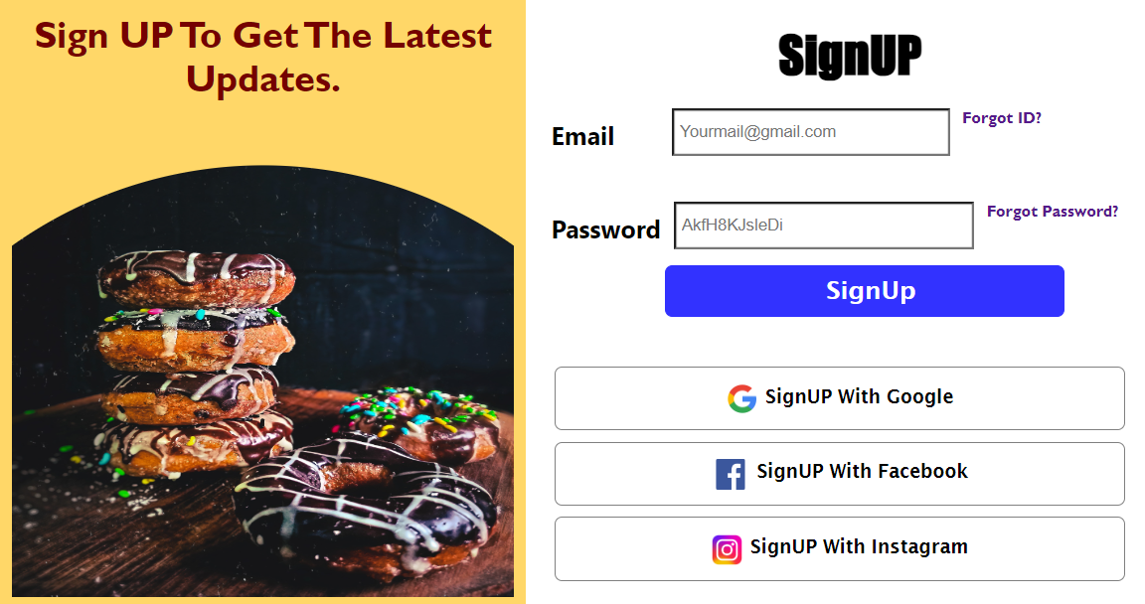

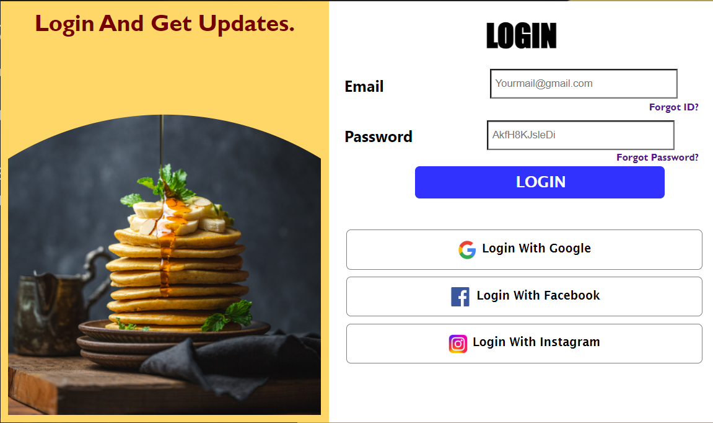

The footer of our recipe sharing website is a subtle yet essential component that adds the finishing touch to the user experience. Crafted with attention to detail, the footer serves as a navigational anchor, providing users with quick access to essential links such as the terms of service, privacy policy, and contact information. It is designed for both functionality and aesthetics, featuring a clean and minimalist layout that complements the overall visual appeal of the website. Additionally, the footer acts as a gateway to our social media platforms, fostering a seamless connection between the website and our broader online community. Through thoughtful design and strategic placement, the footer enhances user satisfaction by offering a well-organized and cohesive conclusion to their culinary journey on our platform.



1. BreakFast Page-:

he Breakfast page is a sunrise symphony of recipes, celebrating the most important meal of the day. From energizing smoothie bowls and wholesome overnight oats to indulgent brunch classics like avocado toast or fluffy pancakes, this page inspires users to kickstart their mornings with a burst of flavor and nourishment. Nutrient-packed options and creative twists on breakfast staples ensure there's something for everyone, whether you prefer a quick grab-and-go option or a leisurely weekend feast.

1. Lunch Page-:

As the sun reaches its zenith, our Lunch page takes center stage, offering an array of culinary creations suitable for midday indulgence. From vibrant salads and hearty sandwiches to international delights like sushi bowls or Mediterranean wraps, users can find diverse lunch options to suit various palates and dietary preferences. The page emphasizes convenience without compromising on taste, providing practical and delicious solutions for busy individuals.

1. Dinner Page-:

As day turns to night, the Dinner page becomes a canvas for culinary artistry. Elegant mains, comforting sides, and decadent desserts grace this page, catering to both weeknight dinners and special occasions. From savory pasta dishes and aromatic curries to succulent grilled entrees, the Dinner page invites users to transform their evenings into memorable culinary experiences. Clear instructions and beautiful imagery guide users through the creation of restaurant-quality dinners in the comfort of their homes.

1. Drinks Page-:

Our Drinks page is a liquid symphony, offering a diverse array of beverages to complement any meal or satisfy a particular craving. From refreshing smoothies and energizing coffees to sophisticated cocktails and soothing teas, this page is a treasure trove for beverage enthusiasts. Users can explore recipes for every mood and occasion, whether they're seeking a morning pick-me-up, a refreshing afternoon sip, or a sophisticated evening concoction.

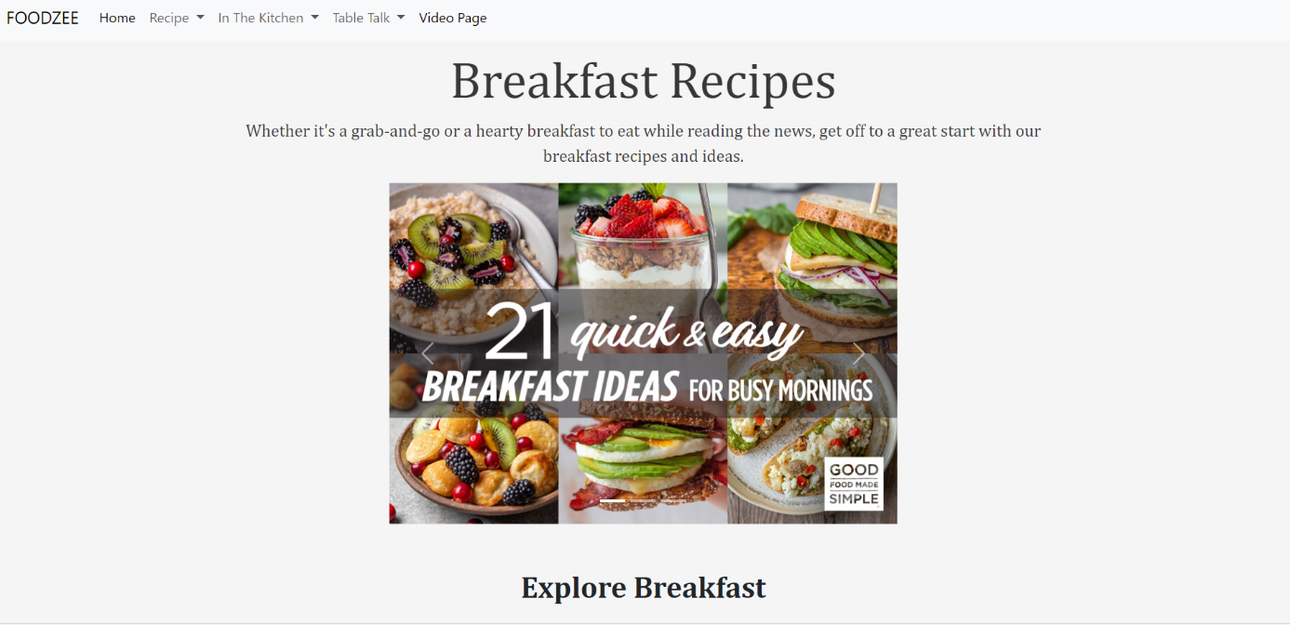

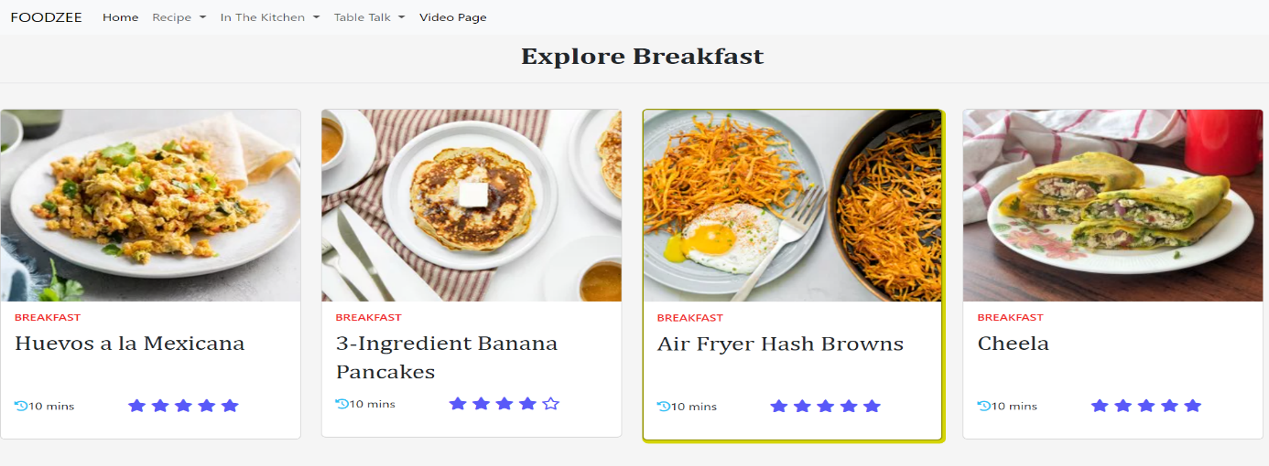

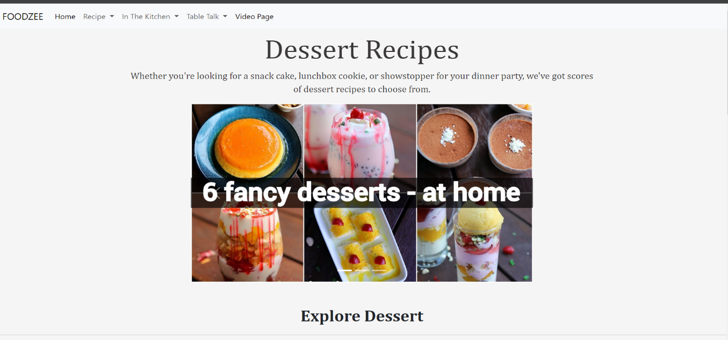

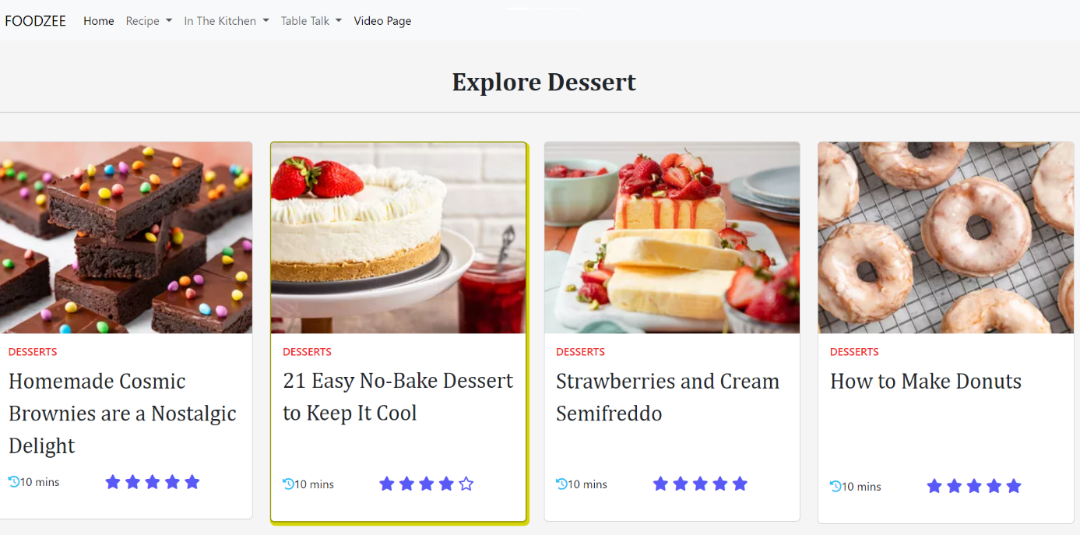

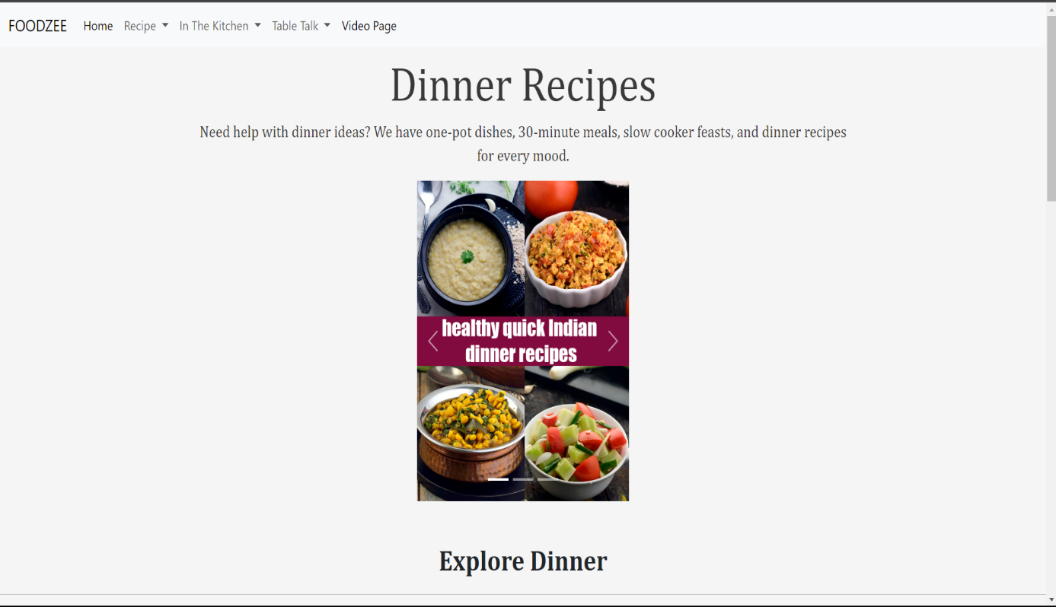

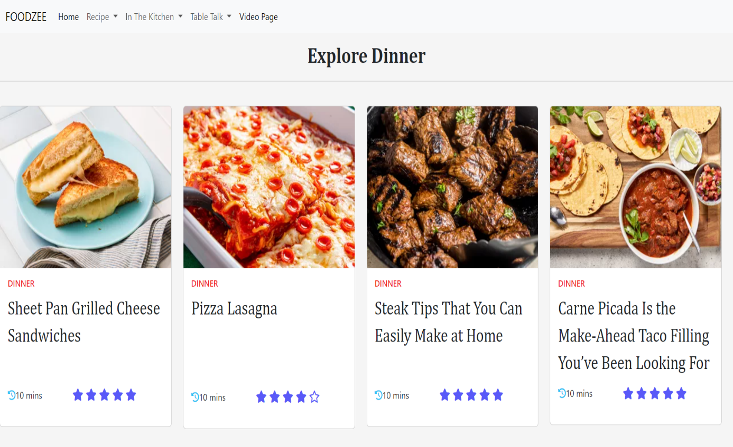

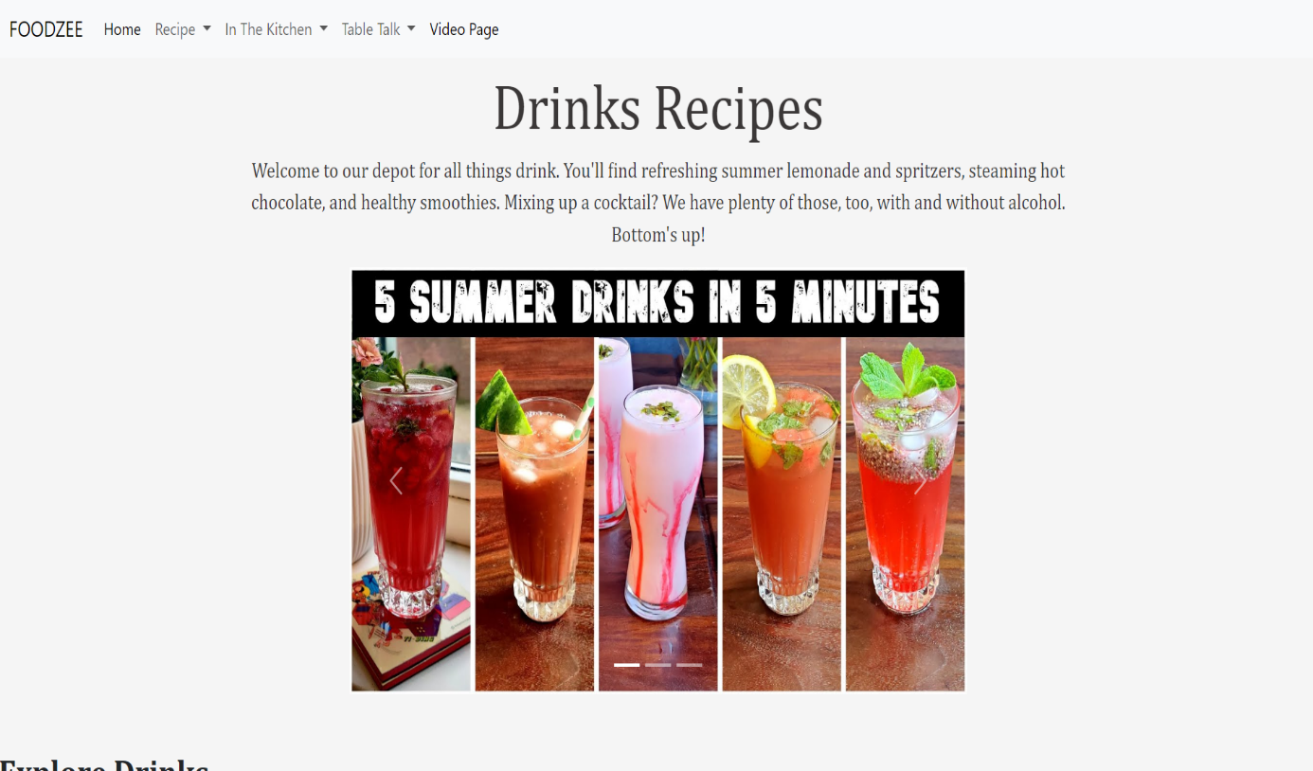

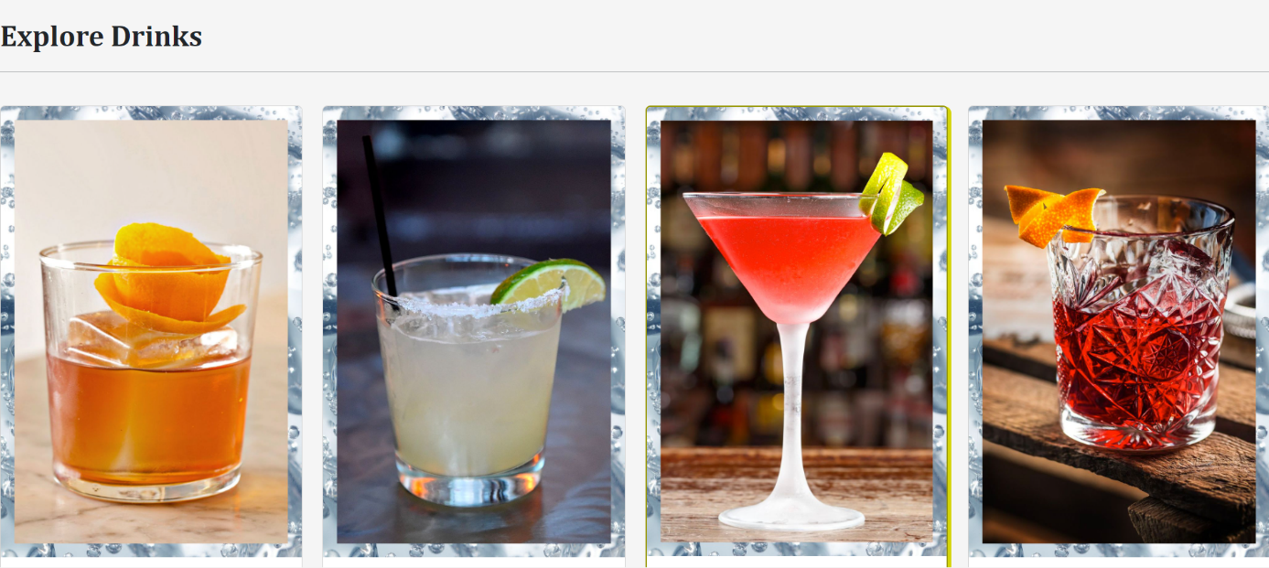

1. Video Page-:

In the digital age of culinary exploration, where the art of cooking meets the power of visuals, our video recipes page emerges as a captivating and educational corner of our recipe sharing website. This dynamic space is meticulously curated to provide users with an immersive culinary experience, combining the richness of traditional recipes with the accessibility and engagement of video content.

The video recipes page is a visual feast that brings recipes to life with cinematic flair. Each video is a culinary story, artfully narrated through vibrant images, dynamic editing, and step-by-step demonstrations. From the sizzle of ingredients hitting the pan to the final plated masterpiece, users are transported into the heart of the kitchen, making the cooking process more accessible and enjoyable.

Beyond mere entertainment, the video recipes page serves as an educational hub, empowering users with practical skills and techniques. Expert chefs and passionate home cooks guide viewers through intricate steps, providing valuable insights into the nuances of each recipe. The visual medium allows for a deeper understanding of cooking methods, presentation tips, and the science behind culinary creations.

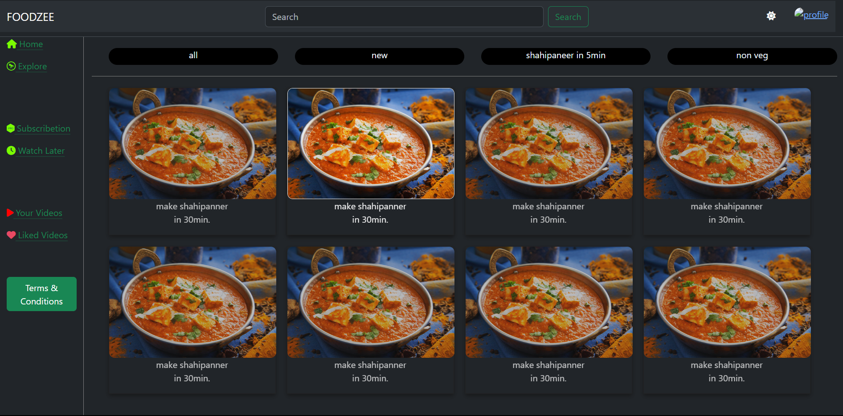

1. A-Z Page-:

The A-Z Recipe Guide is a virtual roadmap, guiding users through an alphabetical expedition of recipes. From appetizers to desserts, this page encapsulates the culinary spectrum, ensuring that users can discover and indulge in a wide array of dishes. Each letter of the alphabet unfolds a new chapter, inviting users to explore and experiment with recipes they might have never considered.

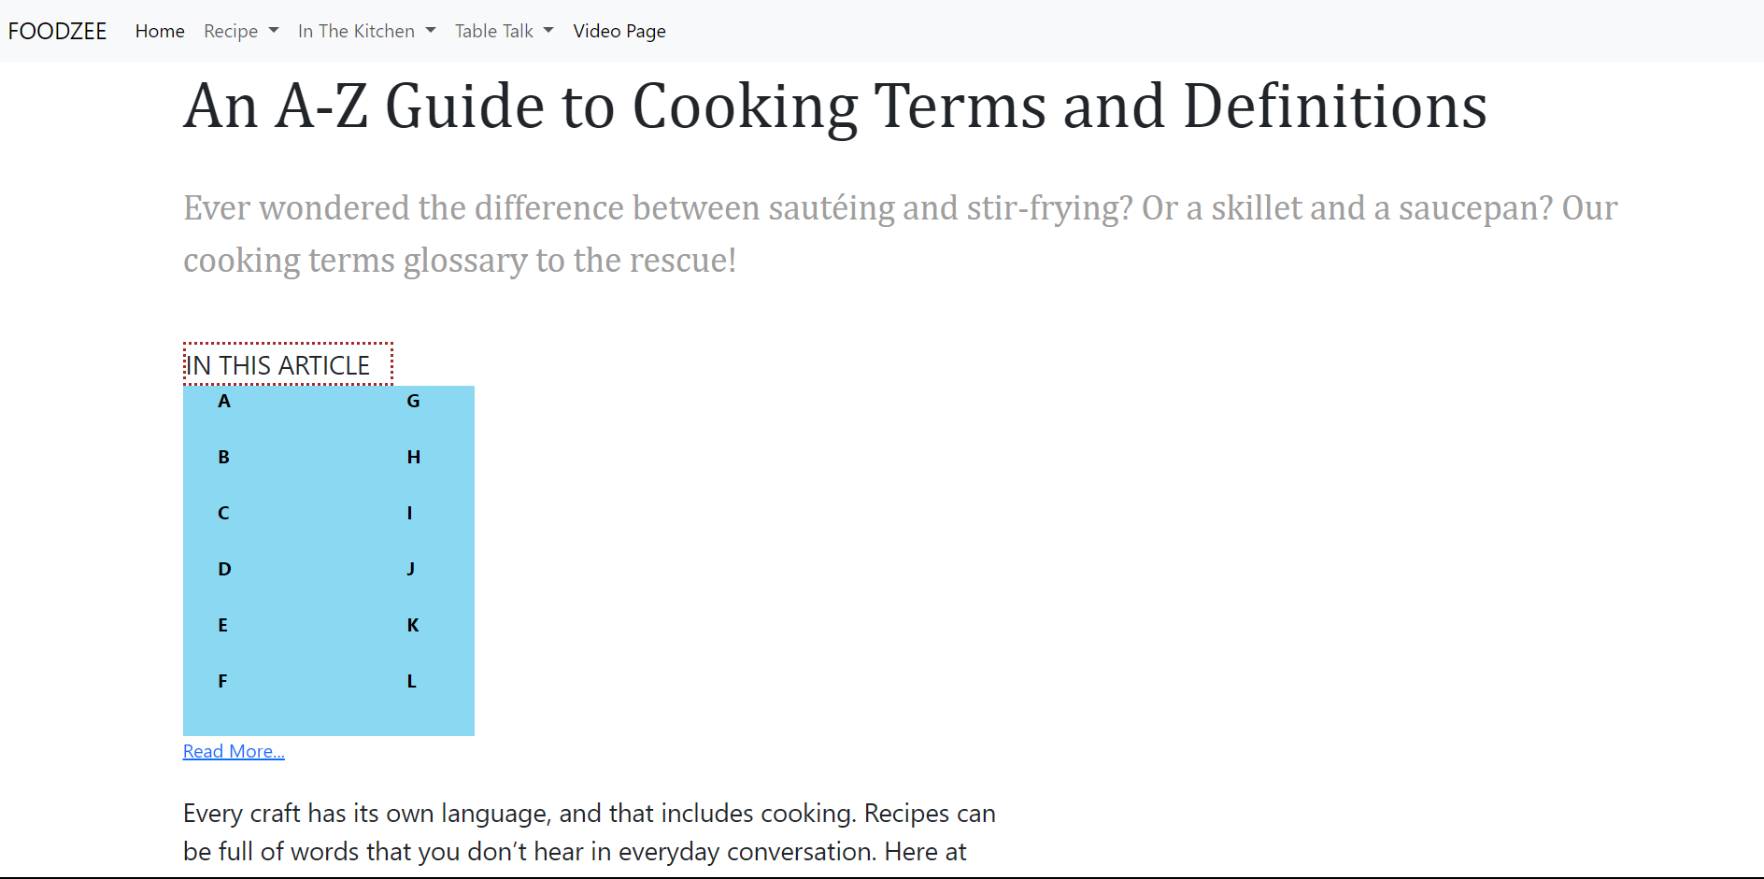

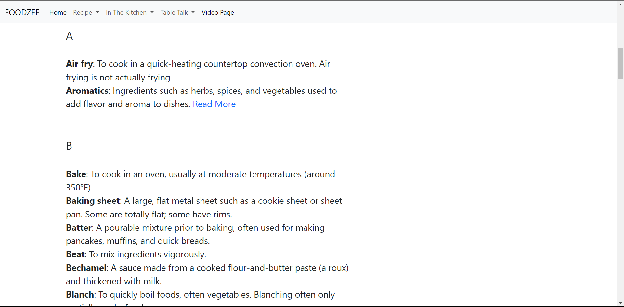

I) About Us page-:

The only purpose of this page is that viewers should feel free to contact us through emails and our phone numbers so that we would clear their doubts about website.

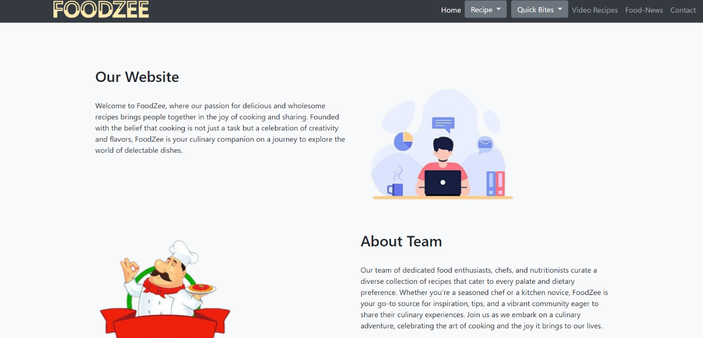

KEY FEATURES

USER ACCOUNT AND LOGIN/SIGNUP-:

This feature allows user to create an account for itself and can use that account to store information. Account helps users to keep record of things they are doing. User can directly create an account by Signup feature or directly login into his/her existing account with login feature.





RECIPE SUBMISSION AND FILTER-:

By using this user will be able to submit their written recipes for other users to see and review. This also allows user to upload images of the dish. Filter feature adds an interactive yet easier method to filter through a variety of recipes. User can filter recipe type their difficulty level and dietary preferences.

VIDEO RECIPES-:

Now Users can not share written recipes but video recipes as well. They can teach each other different recipes through videos and these video will be available in different quality options such as 144P, 240P, 360P, 720P and 1080P. Users can Provide Captions in their video if they don’t understand the speaking language.

RECIPE RATINGS-:

User can now rate the recipes submitted and uploaded by other users by star rating system and help other users to make a difference between two recipes of same kind. Comments section will help users to interact with each other and share information about recipes.

USER NOTIFICATION AND SOCIAL MEDIA SHARING-:

While people do their other work, they can get notifications about their accounts, comments on their recipe and how much people liked their recipe directly on their device notification section. User can Share the Recipe if they like to any platform from our website. They can refer links for video recipe and short texts for written recipe.

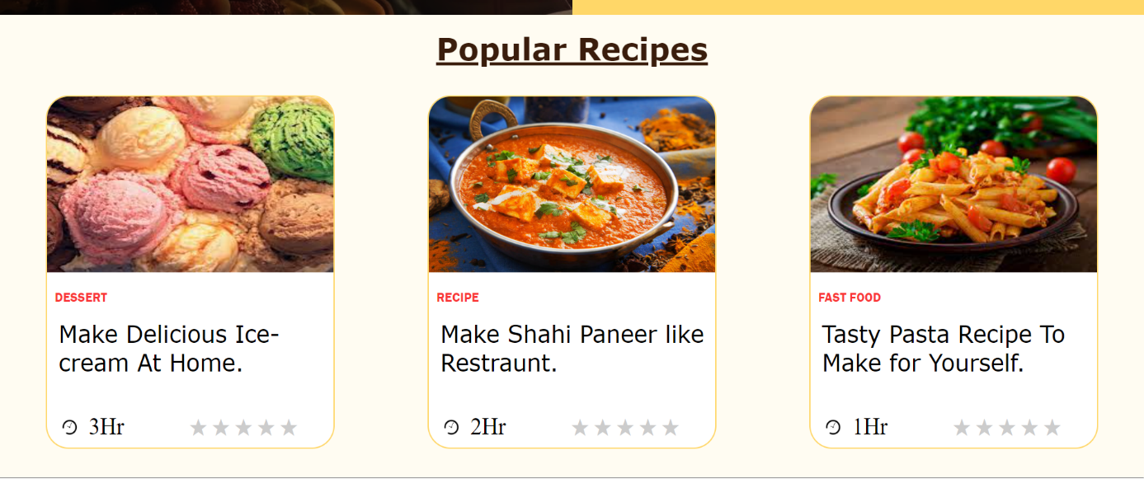

PROJECT ADVANTAGES

RECIPE KNOWLEDE SHARING-:

This website provides a platform to share a knowledge about different recipes , cooking tips. Dietary preferences. This encourages a sense of sharing and learning. Users can learn new cooking techniques, experiment with different cuisines, and enhance their culinary skills by trying out recipes from the platform.

USER ENGAGEMENT-:

Recipe-sharing websites often have high user engagement, as users interact through comments, likes, and sharing. This can lead to a sense of community and social interaction.

RESUME AND PORTFOLIO BUILDER-:

Creating and managing such a website is a valuable addition to your portfolio as a web developer or designer. It showcases your skills in HTML and CSS. The project can serve as a starting point for future development. You can continue to add features, improve user experience, and possibly even monetize the website through ads or premium content.

ACADEMIC ACHIEVEMENT-:

Successfully completing this project demonstrates your ability to conceptualize, design, and develop a web application, which can be a significant achievement in your academic career.

BONUS FEATURES

VIDEO RECIPES-:

Now Users can not share written recipes but video recipes as well. They can teach each other different recipes through videos and these video will be available in different quality options such as 144P, 240P, 360P, 720P and 1080P. Users can Provide Captions in their video if they don’t understand the speaking language.

FAVOURITE SECTION-:

People can now add a written or video recipe to favorites section to view them later or make the recipe their favorites. This feature is essential to help people differentiate their favorite recipe from normal recipe.

ADVANCED SEARCH FILTERS-:

Enhance the search functionality with filters for seasonality, cost, and specific dietary requirements. Filter feature adds an interactive yet easier method to filter through a variety of recipes . User can filter recipe type their difficulty level and dietary preferences.

SUBSCRIPTION OR PREMIUM MEMBERSHIP-:

Offer a premium membership with additional features, such as ad-free browsing, exclusive recipes, or early access to content.

CONCLUSION

In conclusion, a recipe sharing platform website provides a valuable space for culinary enthusiasts to come together, exchange ideas, and explore the rich world of food. It fosters a sense of community, encourages creativity in the kitchen, and allows individuals to discover and share their favorite dishes with a global audience.

As we've discussed, these platforms offer a wide range of benefits, from diverse recipe collections to interactive features like comments and ratings, making them a hub for food lovers everywhere. Whether you're a seasoned chef or a novice cook, recipe sharing websites offer an engaging and enriching experience that brings people closer through the universal language of food. So, join in, share your culinary creations, and savor the delicious journey of exploring new flavors and cuisines with the global recipe-sharing community.

Moreover, the project offers the opportunity to showcase our web development and design skills, making it a valuable addition to our portfolio. It also provides insights into user behavior, which can guide future enhancements. The potential for expansion, monetization, and collaboration adds a layer of excitement and growth prospects.

LIST OF REFERENCES

W3 SCHOOLS-: <https://www.w3schools.com/>

GOOGLE-: <https://www.google.com/>

SIMPLY RECIPES-: <https://www.simplyrecipes.com/>

BENNETTFEELY-: <https://bennettfeely.com/clippy/>

CANVA:- Canva: Visual Suite for Everyone